Hotel Reservation System

* Mohanasundaram
* Ajith Kumar M
* Naveen Kumar T

Introduction :

The database acts as the central repository for data needed to handle the intricacies of reservations for lodging. Fundamentally, the database is the online storehouse where all of the important information is kept, from reservation details and guest profiles to room availability and cost schedules. It functions as a dynamic vault that is always changing in real time, guaranteeing that users—whether they be visitors or hotel managers—have access to current and correct data. The database architecture makes it possible for data to be stored and retrieved efficiently, allowing for quick and accurate transactions in the dynamic world of hotel reservations.

Tables In the DataBase :

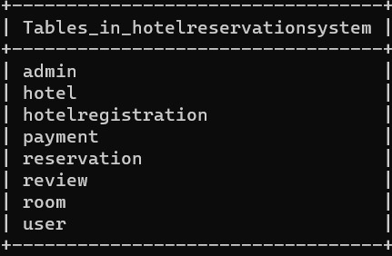

Admin:

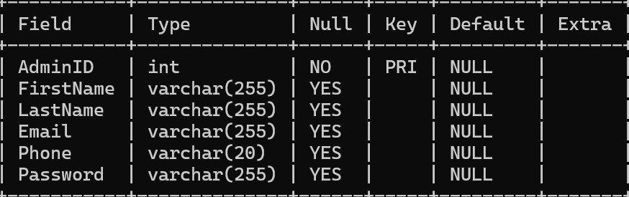

Hotel:

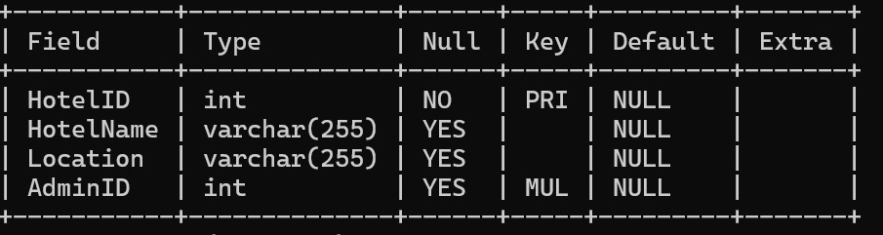

Hotel Registration :

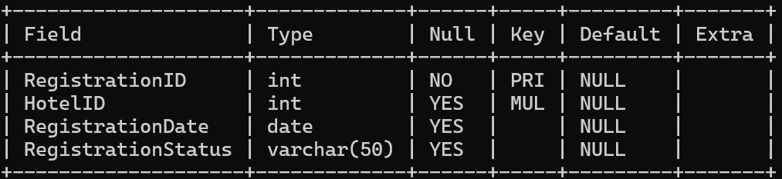

Payment :

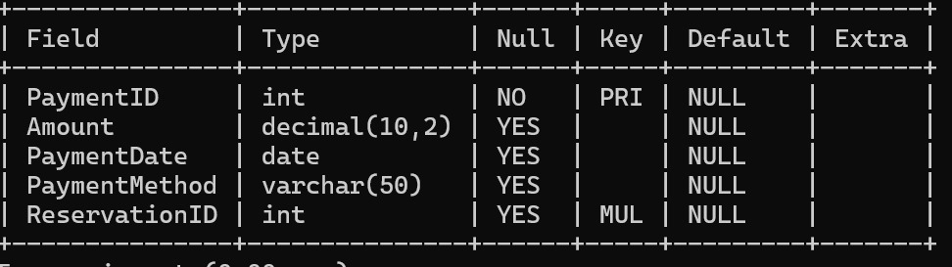

Room :

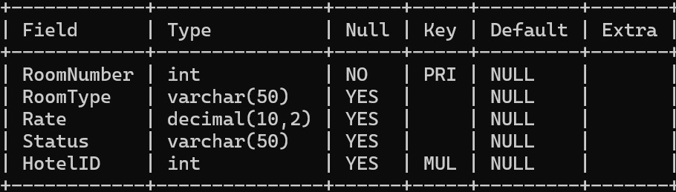

Reservation :

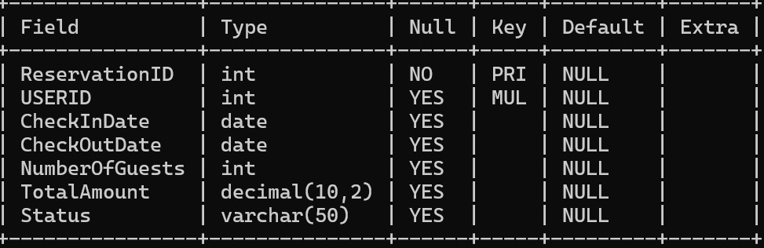

User :

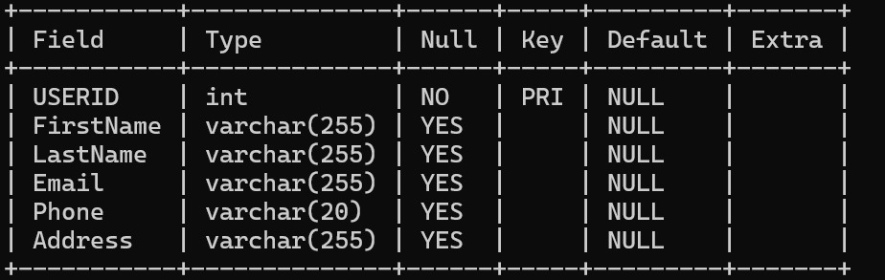

Review :

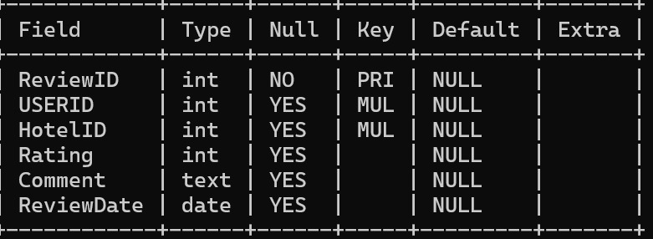

CODE :

-- Customer table

CREATE TABLE Customer (

CustomerID INT PRIMARY KEY,

FirstName VARCHAR(255),

LastName VARCHAR(255),

Email VARCHAR(255),

Phone VARCHAR(20),

Address VARCHAR(255)

);

-- Reservation table

CREATE TABLE Reservation (

ReservationID INT PRIMARY KEY,

CustomerID INT,

CheckInDate DATE,

CheckOutDate DATE,

NumberOfGuests INT,

TotalAmount DECIMAL(10, 2),

Status VARCHAR(50),

FOREIGN KEY (CustomerID) REFERENCES Customer(CustomerID)

);

-- Room table

CREATE TABLE Room (

RoomNumber INT PRIMARY KEY,

RoomType VARCHAR(50),

Rate DECIMAL(10, 2),

Status VARCHAR(50),

HotelID INT,

PRIMARY KEY (RoomNumber),

FOREIGN KEY (HotelID) REFERENCES Hotel(HotelID)

);

-- Payment table

CREATE TABLE Payment (

PaymentID INT PRIMARY KEY,

Amount DECIMAL(10, 2),

PaymentDate DATE,

PaymentMethod VARCHAR(50),

ReservationID INT,

FOREIGN KEY (ReservationID) REFERENCES Reservation(ReservationID)

);

-- Admin table

CREATE TABLE Admin (

AdminID INT PRIMARY KEY,

FirstName VARCHAR(255),

LastName VARCHAR(255),

Email VARCHAR(255),

Phone VARCHAR(20),

Password VARCHAR(255)

);

-- Hotel table

CREATE TABLE Hotel (

HotelID INT PRIMARY KEY,

HotelName VARCHAR(255),

Location VARCHAR(255),

AdminID INT,

FOREIGN KEY (AdminID) REFERENCES Admin(AdminID)

);

-- CustomerPreferences table

CREATE TABLE CustomerPreferences (

PreferenceID INT PRIMARY KEY,

CustomerID INT,

FeatureID INT,

FOREIGN KEY (CustomerID) REFERENCES Customer(CustomerID),

FOREIGN KEY (FeatureID) REFERENCES HotelFeatures(FeatureID)

);

-- HotelFeatures table

CREATE TABLE HotelFeatures (

FeatureID INT PRIMARY KEY,

FeatureName VARCHAR(255)

);

-- HotelRegistration table

CREATE TABLE HotelRegistration (

RegistrationID INT PRIMARY KEY,

HotelID INT,

RegistrationDate DATE,

RegistrationStatus VARCHAR(50),

FOREIGN KEY (HotelID) REFERENCES Hotel(HotelID)

);

CREATE TABLE Review (

_ReviewID INT PRIMARY KEY,

_USERID INT,

_HotelID INT,

Rating INT,

Comment TEXT,

ReviewDate DATE,

FOREIGN KEY (_USERID) REFERENCES USER(_USERID),

FOREIGN KEY (_HotelID) REFERENCES Hotel(_HotelID)

);